Contents
Reconcile OUTSIDE Allergies, Immunizations, Meds & Problem List 1
Reconcile Allergies: 3
Reconcile Medications: 4
Reconcile Problem List: 4
Reconcile Immunizations: 5
Review Medications, Allergies, & Problem List During the Visit 7

Reconcile OUTSIDE Allergies, Immunizations, Meds & Problem List
***These items pending reconciliation DO affect immunization care gaps and Health Maintenance advice. It is very important to reconcile at EVERY visit. (see Immunizations for more info)

Recommendation: It can be more efficient and helpful to reconcile outside information FIRST, and then complete the review and modification of the patient’s record after all necessary information has been pulled in. This helps to prevent extra steps taken for adding information manually and allows for ease of deletion or resolution of health information.

- During a patient encounter, if there are Allergies, Immunizations, Medications or items on the Problem List to be reconciled, you will see an orange banner located in the header of that section to indicate items need to be reconciled. This will alert within the Snapshot and in your Start Review window.

- To begin reconciling the outside information, click the hyperlink within the orange banner or ‘Go Reconcile’ to jump to and open the Reconcile Outside Info Activity.
- In the Reconcile Outside Info Activity you can:
  - Add , Discard , or Update/Merge any new or existing information.
  - Click the ‘Next’ button to move to the next tab and reconcile the corresponding information.
  - Once complete, click ‘Accept’ to save all selections.
  - Recommendation: Reconcile all 4 tabs before clicking accept. Clicking the ‘Accept’ button will close the Reconcile Outside Info window.
  - General FYI’s:
- This orange banner will also show for any Pre-Check In items the patient completed in MyChart. Items from Pre-Check will appear as Patient Reported in the four source fields. These will need final review and approval by a provider to be added into the patient record.
- If everything in a source field is not applicable and does not need added to or is already in the patient’s record, you can select ‘Discard Remaining’ for a faster reconciliation process.

Reconcile Allergies:

- From the Allergies tab, click the ‘Add/+’ button to add this allergy to the patient’s current allergies.
- You will see a box requiring you to add a reaction. Add the appropriate reaction and then click ‘Accept’.
- If the allergy should not be added to the patient’s record, select the trash can or ‘Discard’ button.
- Once the allergies have been added or discarded, click the ‘Accept & Next’ button in the bottom right corner to move on to the next reconciliation field.

Reconcile Medications:
- Select the orange banner or hyperlink under medications. If you chose ‘Accept & Next’, you will be jumped to the next reconciliation tab automatically.
- Once the medications tab opens, review the information and click the ‘Add/+’ button for those medications you wish to add to the patient’s current medications list.
- The Medication Details window opens to add missing details regarding the medication. You can make changes here, if necessary, and then click ‘Accept’ in the bottom right corner.
- If medications do not need to be added to the patient chart, select the trash can or ‘Discard’ button to discard them.
- Once the medications have been added or discarded, click the ‘Accept & Next’ button in the bottom right corner to move to the next selections field, or ‘Accept’ to close the reconciliation window.

Reconcile Problem List:
- Click the orange banner or hyperlink to ‘Go Reconcile’ information.
- From the Problems tab, click the ‘Add/+’ button for those problems you wish to add to the patient’s current problem list.
- For any problems that do not need to be added to the patient’s current problem list, select the trash can or ‘Discard’ button.
- Once the problems have been added or discarded, click the ‘Accept & Next’ button to continue with reconciliation. Select ‘Accept’ to finalize and close the reconciliation window.

Reconcile Immunizations:
***Health Maintenance and Care Gaps now account for immunizations that are not reconciled from outside sources. If there is an immunization awaiting reconciliation, it will not suggest ordering that vaccine in the dynamic well SmartSet or show as an overdue care gap. However, the Immunization Record does not show these immunizations until after they have been reconciled.*** (Ex. 4 year old patient has received 4 DTaPs in office. There is a 5th DTaP from outside institution awaiting reconciliation. Prior to reconciliation, it will not show DTaP as due in the dynamic well SmartSet or as an overdue care gap. However, the patient’s immunization record will only show the 4 DTaPs.)
- Select the orange hyperlink to jump to the Immunizations Reconcile Activity.
- Click the ‘Go Reconcile’ button to begin reconciling.
- Once this activity opens, you have the option to do the following:
  - Add/+ individual or all immunizations
  - Discard/ immunizations that should not be added or are duplications
  - Update immunization information such as add missing manufacturer, lot number, or dose information.
- Once the immunizations have been added or discarded, click ‘Accept & Next’ to move on or ‘Accept’ to finish and close the reconcile window.

NOTE: When viewing Immunizations that need to be reconciled, a yellow question mark may appear next to the immunization name. If this appears, you will not be able to match the outside immunization to our list. When selecting the ‘Add All’ button, you will have the choice to replace the immunization with one that matches our database information.
  - General FYI’s:
- Be DILIGENT to verify immunization accuracy. Make sure to not add any duplicate immunizations. There is potential that the vaccines suggesting being imported are not for this patient. There have been cases of mismatching patients. The Mismatch Vaccine OPA will continue to populate appropriately and may provide additional safeguards. Refer to this education for immunization reconciliation tips: Immunization Reconciliation My Learning.
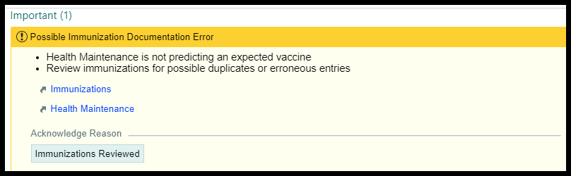

Review Medications, Allergies, & Problem List During the Visit
Providers are responsible for reviewing and reconciling a patient’s medication list, allergy list, and problem list at EVERY visit. Ensuring accuracy is crucial for patient care, safety, and legal protection. In most cases, the parent/guardian will review it during pre-check-in via the tablets or via MyChart. Clinical staff DO NOT review this during rooming.
- You can review the medication in two different sections:
  - Home Medications in Rooming Tab
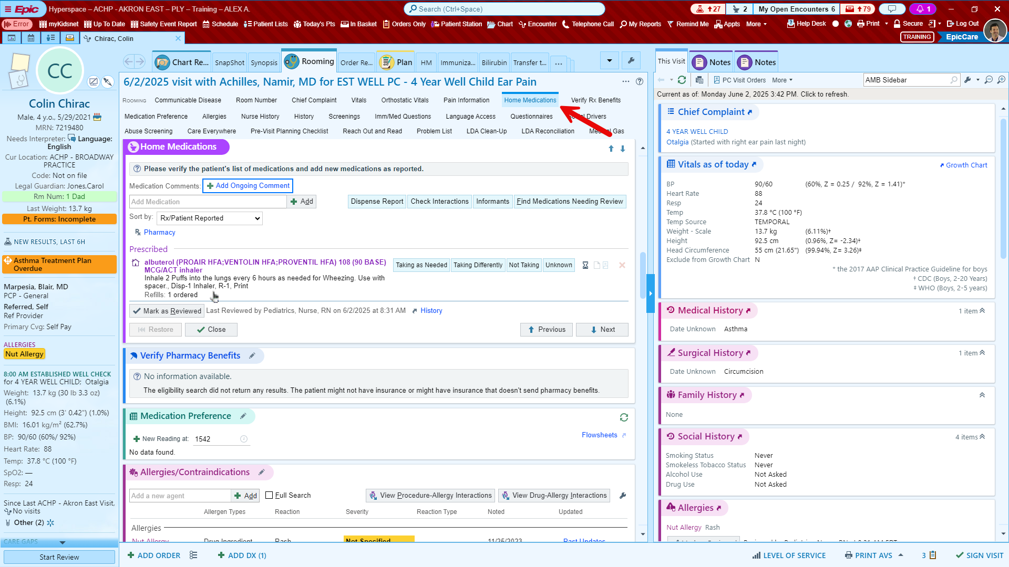
  - Med Management in Plan tab
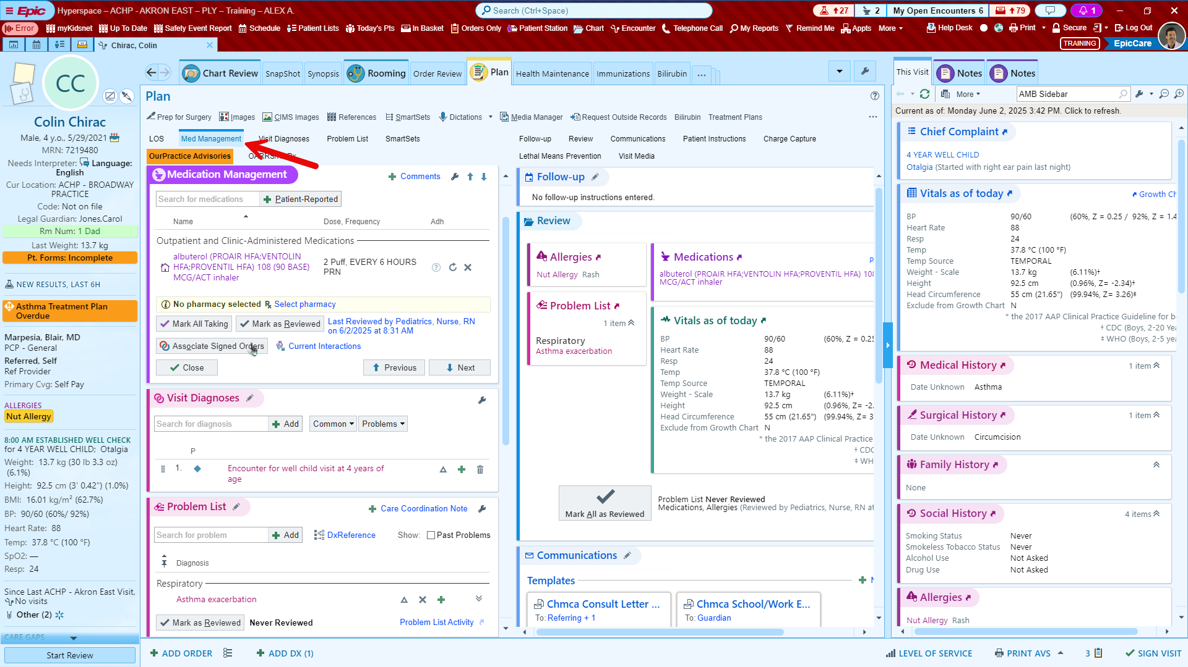

- Use the Add Medication search bar to add any medications that the patient is taking at home. Any medications that they are no longer taking can be removed from the list, using the X
  - Rooming Tab Option
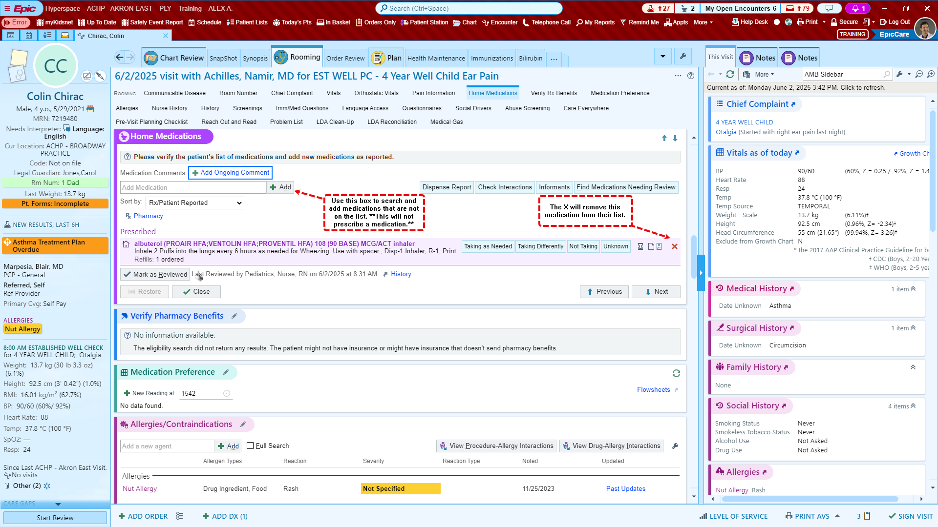
  - Plan Tab Option
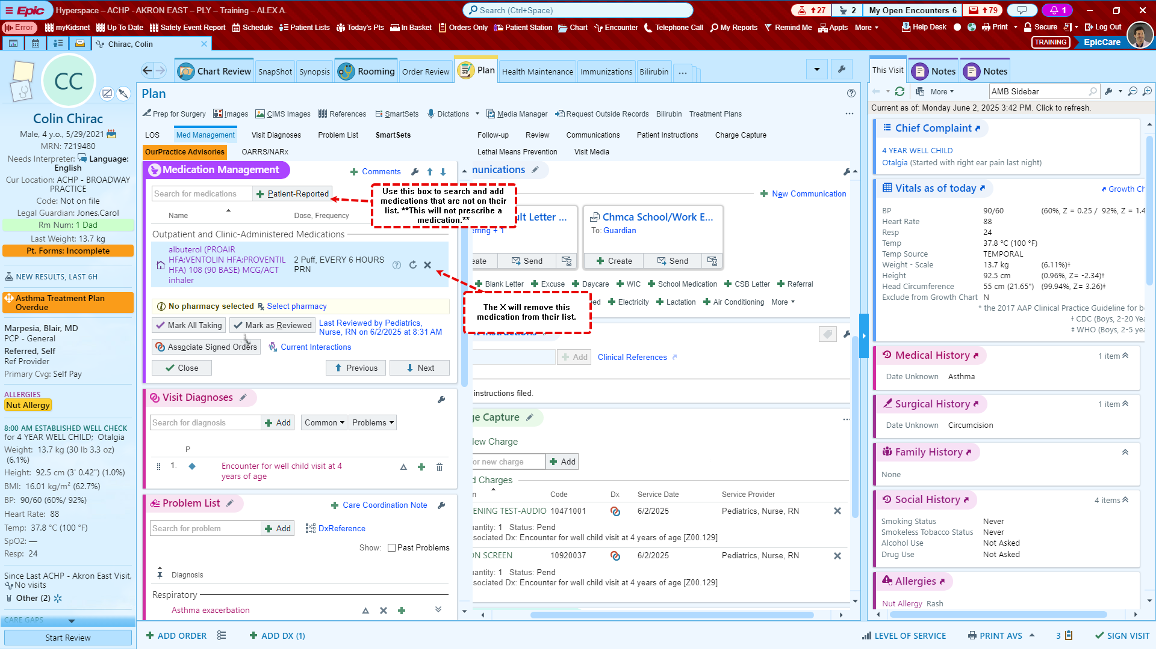

- Tip: On the Plan tab under Med Management, you can change your medication list to organize by Order Mode, Associated Dx, or Pharm Subclass if you prefer.
